Trylle Dough

This flour-based modling dough can be used to make all sorts of Christmas decorations. The dough is basically flour, salt and water, with a little oil, which is then dried and baked at a low temperature.
I used it to make a the advent wreath in the picture, but it can be used for simpler decorations as well, like biscuit shapes to paint and hang on the tree.
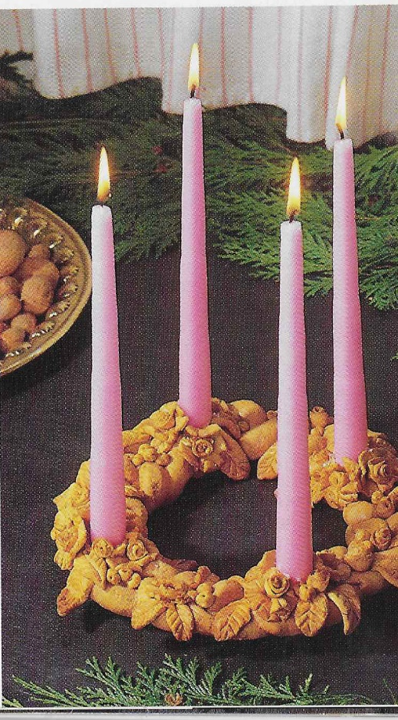

The dough is made from
80 ml plain flour
20 ml fine salt
30 ml water
¼ teaspoon oil (to make it easier to handle – can be omitted)
Mix the ingredients and work it into a smooth paste.

This will make enough dough for the wreath shown.

To make the wreath a ring on greaseproof paper using a dinner plate, or cake tin as a guide.
Keep about ¼ of the dough for the decorations and roll the rest of it into three sausages which you then plait to form the base ring.
Use candles to make hollows in the ring for the four candles. Theses should be a bit larger than the candles that you are going to be using as the dough shrinks on baking.
Roll out the remaining dough into a thin layer which you can cut into leaf shapes, flower petals and so on. You can also make little flowers out of the dough. The picture has a lot of decoration, but it also looks good with just leaves.
Stick the flowers and leaves onto the ring using water.
Bake at 150C for 1 ½ hrs.
Once it has cooled, you can laker it so that it will keep. I kept mine for about 10 years before it broke.

